**project Design Phase-I**

**Solution Architecture**

|  |  |
| --- | --- |
| Date | 20/10/2002 |
| Team ID | PNT2022TMID43503 |
| Project Name | Natural Diaster Intensity Analysis and Classification using Artificial  Intelligence |

**Solution Architecture :**

Natural disasters not only disturb the human ecological system but also destroy the properties and critical infrastructures of human societies and even lead to permanent change in the ecosystem. Disaster can be caused by naturally occurring events such as earthquakes, cyclones, floods, and wildfires. Many deep learning techniques have been applied by various researchers to detect and classify natural disasters to overcome losses in ecosystems, but detection of natural disasters still faces issues due to the complex and imbalanced structures of images. To tackle this problem, we developed a multilayered deep convolutional neural network model that classifies the natural disaster and tells the intensity of disaster of natural The model uses an integrated webcam to capture the video frame and the video frame is compared with the Pre-trained model.

**Solution Architecture Diagram:**

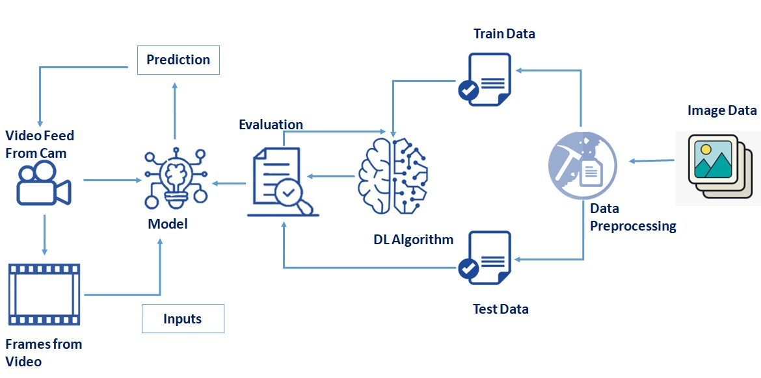

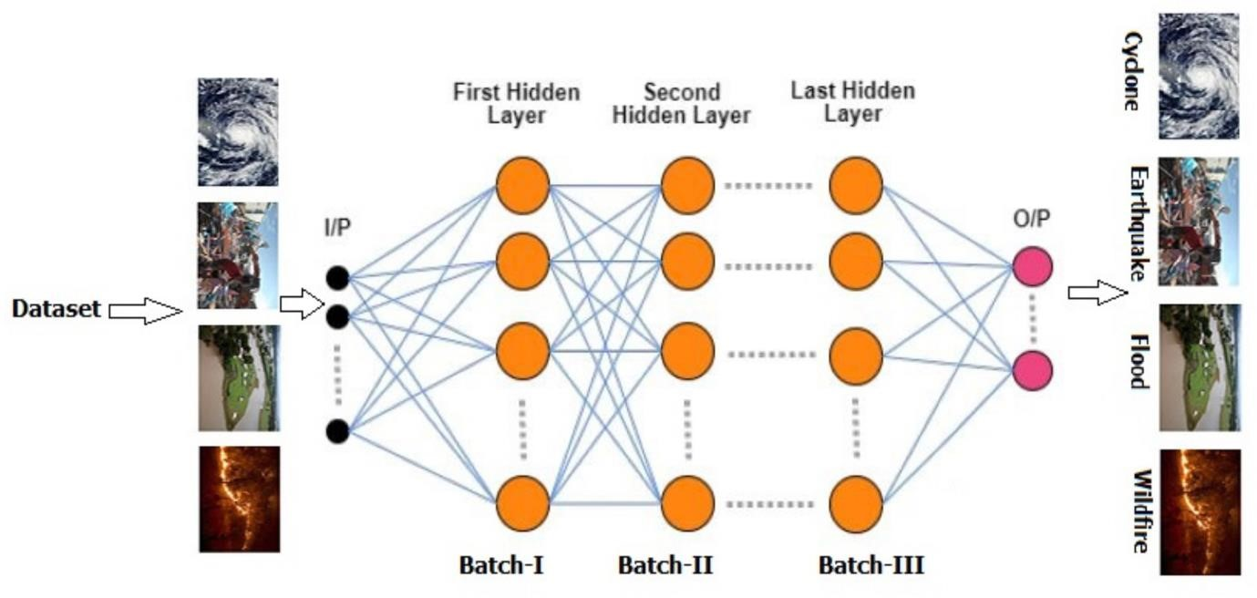

The stakeholder engagement model research found that 50% of change initiatives are clear failures and only 34% are clear successes. A big reason for this is that projects are often being driven at the executive level, but not enough is being done to engage with change management stakeholders at other levels to gain their support and buy-in.